Chapter 10: Review Exercise Solutions

R10.1
The following require a cast:
c = i; // c = (C) i;
i = j; // i = (I) j;

R10.2
None of them will throw an exception.

R10.3
The following are legal:
a. e = sub;
c. sub = (Sandwich) e;
The following statement will compile but throw an exception at run time.
f. e = (Edible) cerealBox;

R10.4
When casting a primitive type, the user acknowledges to the compiler that information may be lost. When casting objects, the user acknowledges to the compiler that the cast may cause an exception.

R10.5
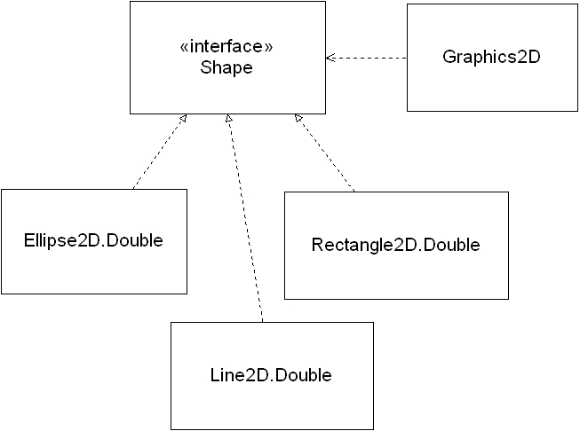

R10.6
a. Rectangle a = r;
b. Shape b = r;
f. Serializable f = r;
g. Object g = r;

R10.7
The call Rectangle r = s.getBounds(); is an example of polymorphism because the Shape interface declares the method, and each class that implements the interface (Rectangle2D.Double, Ellipse2D.Double, Line2D.Double, etc.) provides its own implementation of the method. The correct implementation is picked at run time.

R10.8

The Employee class must
1) implement Measurable and
2) include a method
public double getMeasure()

To use the second solution in 10.4, you
1) create an interface Measurer that defines a callback method (measure) and
2) you create a small helper class with the method that tells the average method how to measure the objects
public double measure(Object anObject)

The callback method decouples your class with other classes. It is a more generic and flexible solution . It is no more difficult to implement than a pure interface solution.

R10.9

You will get a compiler error. The String class does not implement the Measurable interface.

R10.10

A callback is objtained by implementing the Measurer interface. Provide a class StringMeasurer that implements Measurer.
public class StringMeasurer implements Measurer
{
public double measure(Object anObject)
{
string aString = (String) anObject;
double length = aString.length();
return length
}
}

Now you need to construct an object of the StringMeasurer class and pass it to the average method.

Measurer stringMeas = new StringMeasurer();
String[] strings = { … };

double averageLength = Data.average(strings, stringMeas);

R10.11

You will get an error. When the callback method is used, a String object will be passed to a method that id designed for calculating the area of a Rectangle object. String objects do not have getWidth() and getHeight() methods.

R10.12
The f method can access the variables b, t, and x.

R10.13
The compiler gives an error saying that the local variable is accessed from within inner class and needs to be declared final:
local variable a is accessed from within inner class; needs to be declared final
If we change the variable so that it is declared as final, then the inner class can access it, provided it does not try to assign a new value.

R10.14
We would need to put each class (InvestmentViewer1 and AddInterestListener) in its own file. With this change, the class AddInterestListener is no longer able to access the account variable. Thus, we need to add a "private BankAccount account" variable to the class AddInterestListener, and have it receive the bank account in the constructor.

R10.15
An event is an external activity to which a program may want to react. For example, “user clicked on button X” is an event.
An event source is the user-interface component that generates a particular event. Event sources report on events. When an event occurs, the event source notifies all event listeners.
An event listener belongs to a class that is provided by the application programmer. Its methods describe the actions to be taken when an event occurs.

R10.16
With a console application, the programmer is in control and it can ask the user for input, in the order that is most convenient for the program.
With a graphical user interface application, the programmer lays out the various elements for user input. Then the user is in control. The user can click and type into the components in any order, and the programmer must be able to cope with that variety.

R10.17
An ActionEvent is generated when the user-interface library has detected a particular user intent, such as clicking on a button or hitting ENTER in a text field.
A MouseEvent is generated whenever the user moves or clicks the mouse.

R10.18
An ActionListener is only interested in one notification: when the action happens.
A MouseListener has multiple methods because there are several potentially interesting mouse events, such as pressing, releasing, or clicking the mouse button.

R10.19
Yes–a class can be the event source for multiple event types. For example, a JButton is the event source for both mouse events and action events.
You can listen to the mouse events of a button, simply by installing a mouse listener:
button.addMouseListener(mouseListener);
You might want to do that for example to make the button glow in a different color whenever the mouse hovers over it.

R10.20
Every event carries the source object. You can retrieve it with the getSource method.
A mouse event has the following additional information:
- the x- and y- component of the mouse position
- the click count
An action event has the following additional information:
- the command string associated with the action
- the modifier keys held down during the action event
Hint: This information can be found in the API documentation.

R10.21
Event listeners often need to access instance variables from another class. An inner class can access the instance variables of the outer class object that created it. Thus, it is convenient to use inner classes when implementing event listeners.
If Java had no inner classes, we could pass the values of instance variables needed to be accessed to the event listener constructor, so that local references/copies can be stored in the event listener object.

R10.22
The paintComponent method is called by the GUI mechanism whenever it feels that a component needs to be repainted. That might happen, for example, because the user just closed another window that obscured the component.
A programmer calls the repaint method when the programmer feels that the component needs to be repainted (for example, if the state of the object has changed). That call is a request to the GUI mechanism to call paintComponent at an appropriate moment.

R10.23
A frame is a window to which you can add a component to be displayed on the screen. A frame can be displayed on its own, even if it is empty. However, we cannot simply add multiple components directly to a frame–they would be placed on top of each other. A panel is a container to group multiple user-interface components together. A panel needs to be added to a frame to be displayed.

